July 23rd, 2017

Bought the Arduino Pro Mini along with the ESP8266, to establish a WiFi based Client-Server communication.

Since Arduino Pro Mini does now have any USB interface. It was hooked up with another Arduino to flash a test program on it. Arduino Uno was used to program it. The ATMEL chip had to be taken off to make it work as an USB FTDI interface to program the Arduino Pro mini.

Next the ESP8266 was connected, but it worked only a first few times. But then I realized, the module is very sensitive and had to have a supply of 3.3V at VCC and RX pins. Since the module was damaged, there was no other option but to buy a second one. The connections were made as follows.

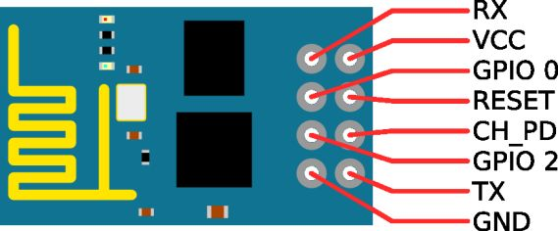

The VCC was connected to 3.3V using a 3.3V Voltage regulator or better, a Buck converter to step down the arduino 5V output but using an independent power supply is recommended or else the module may reset for time to time.

CHECK THE ARROWS NEXT TO THE TX AND RX PINS. If there’s an ARROW (regardless of the text next to it) pointing towards the pin, it’s an RX pin, if the arrow is point away it’s a TX pin. If there are no arrows, in most cases you may follow the text next to the pins.

Most Arduino’s have arrows for example: Arduino Uno, Mega, Due etc… Note that there are no arrows for Arduino Pro Mini.

The RX pin needs to be connected to the TX pin (remember the arrows) of the Arduino through a voltage divider network to ramp it down to 3.3V, since the TX pins on the arduino supplies 5V.

The CH_PD needs to be connected to VCC.

The TX pin needs to connect to Arduino’s RX pin (No need for any additional components in between).

All the GND pins need to be connected at a common ground node.

When uploading the code:

The GPIO 0 pin needs to be grounded before starting up the module to upload any code. And then reset the module without the ground pin connected for the code to run.

This needs to be repeated every time a code is uploaded, i.e, Ground GPIO 0, Start the module, Upload code, take the ground wire off from GPIO 0, Reset. Repeat for consecutive uploads.

Creating dedicated buttons for ground and reset is advised to make things easier.

The following is a screenshot of a test code for sending and receiving TCP messages.

